Scopophobia Modelling List
Overview：
I would like to receive all (or most) of the FBX files by email before the final week of the Easter holidays (before 13 April).
All the models are final versions that do not require further modification; I can incorporate them directly into the game and submit them as they are (complete with textures and colours).
Below, I will provide a list of all the models I require. Each item on the list must be in a separate FBX files; the objects for the entire level must not all be contained in a single file.
FBX Files List：The list is from most important to least important. You can email them to me as and when you complete each one.
Supermarket Part:
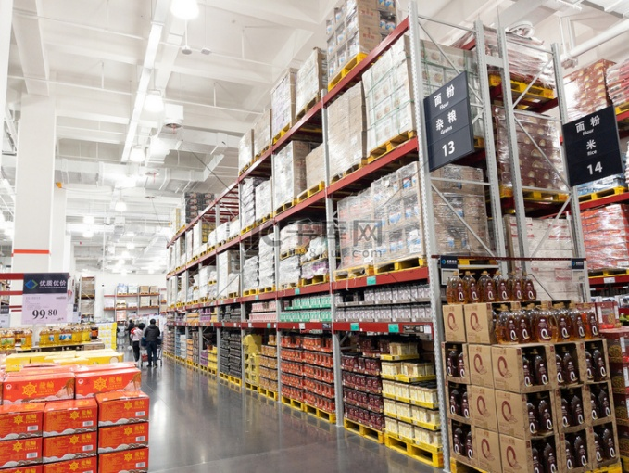
- Food shelves (various sizes)
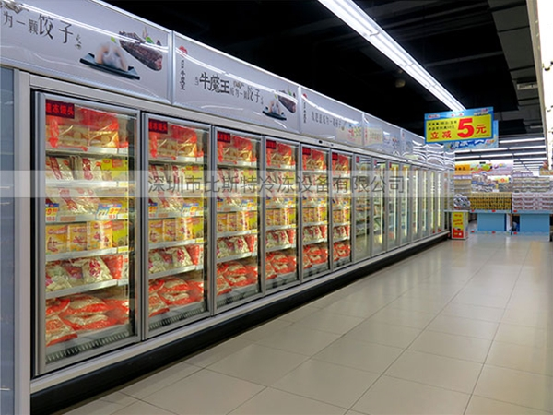
- Open-front freezer (only need to create the model once; I can reuse it)
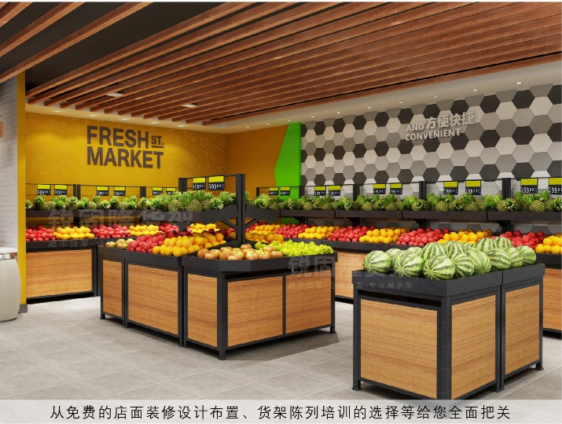
- Merchandiser (only need to create the model once; I can reuse it)
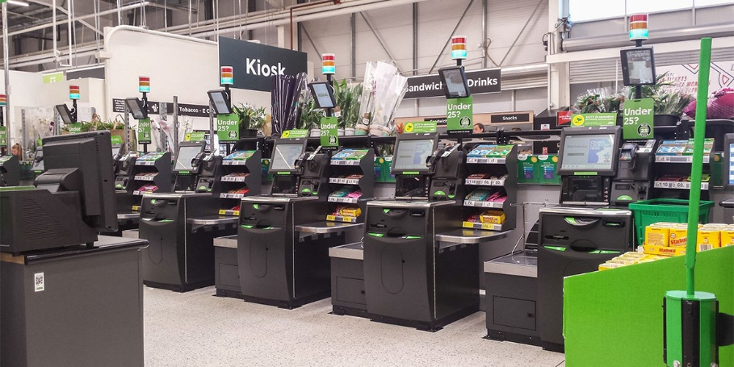
- Self-service checkout (only need to create the model once; I can reuse it)
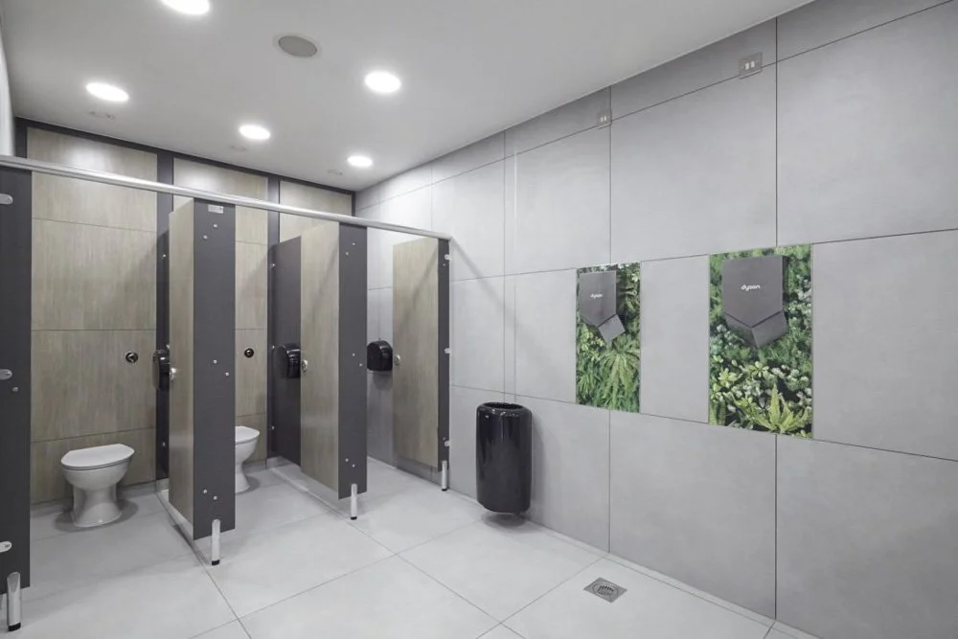
- Supermarket public toilets (only need to create one toilet and one partition; I can reuse it)
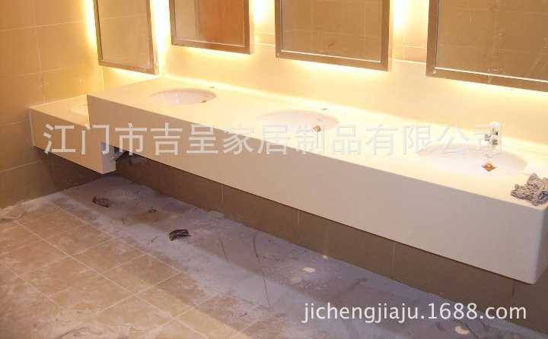
- Bathroom washbasin
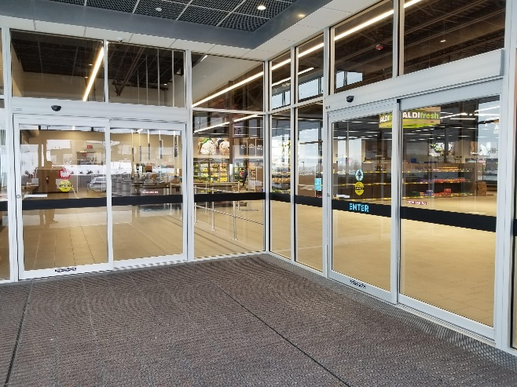
- Sliding door
- Vegetable, fruit, cans, Packaged food and toys (Teddy bear, plants)
- The floors, walls and ceilings of the supermarket
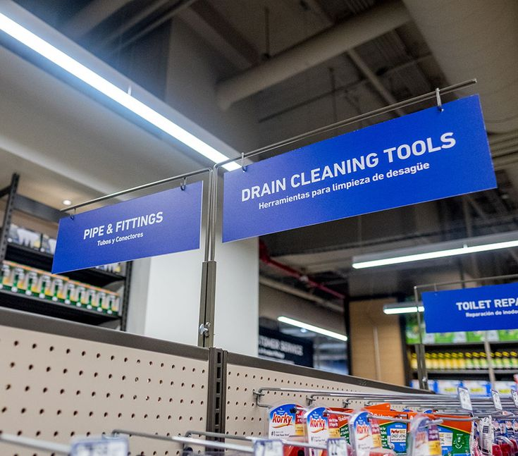
- Wayfinding sign (Signs for the toilets, signs for each food area)
Character Room Part:
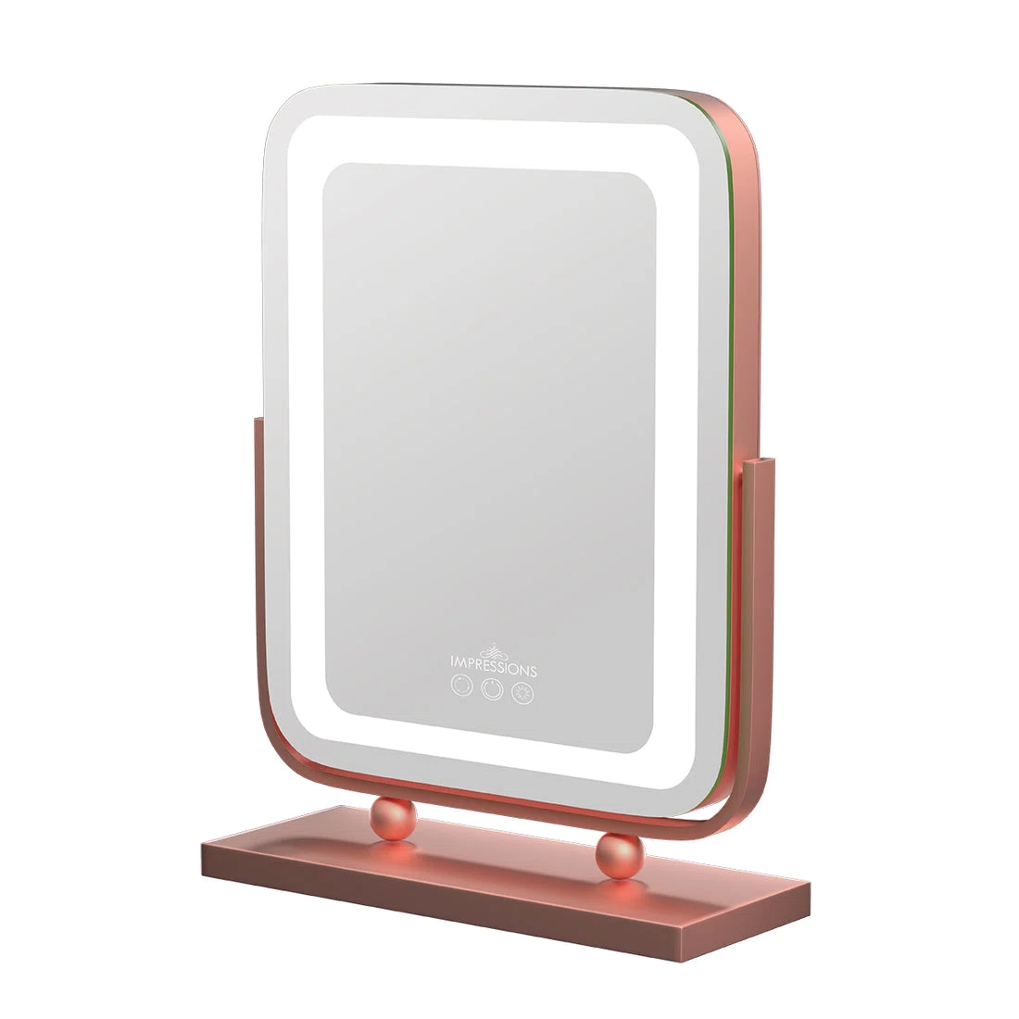
- Mirror
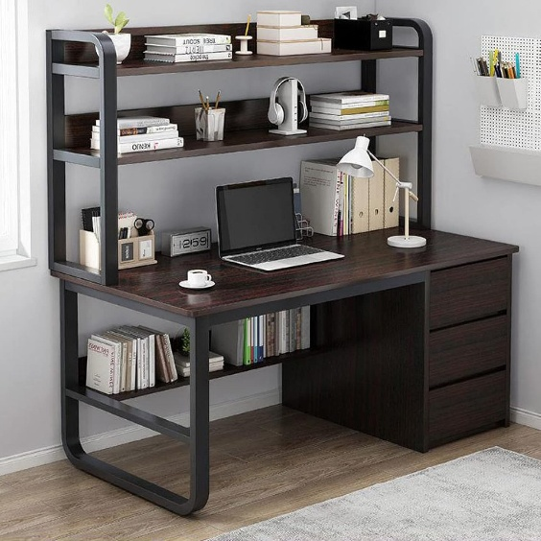
- Desk
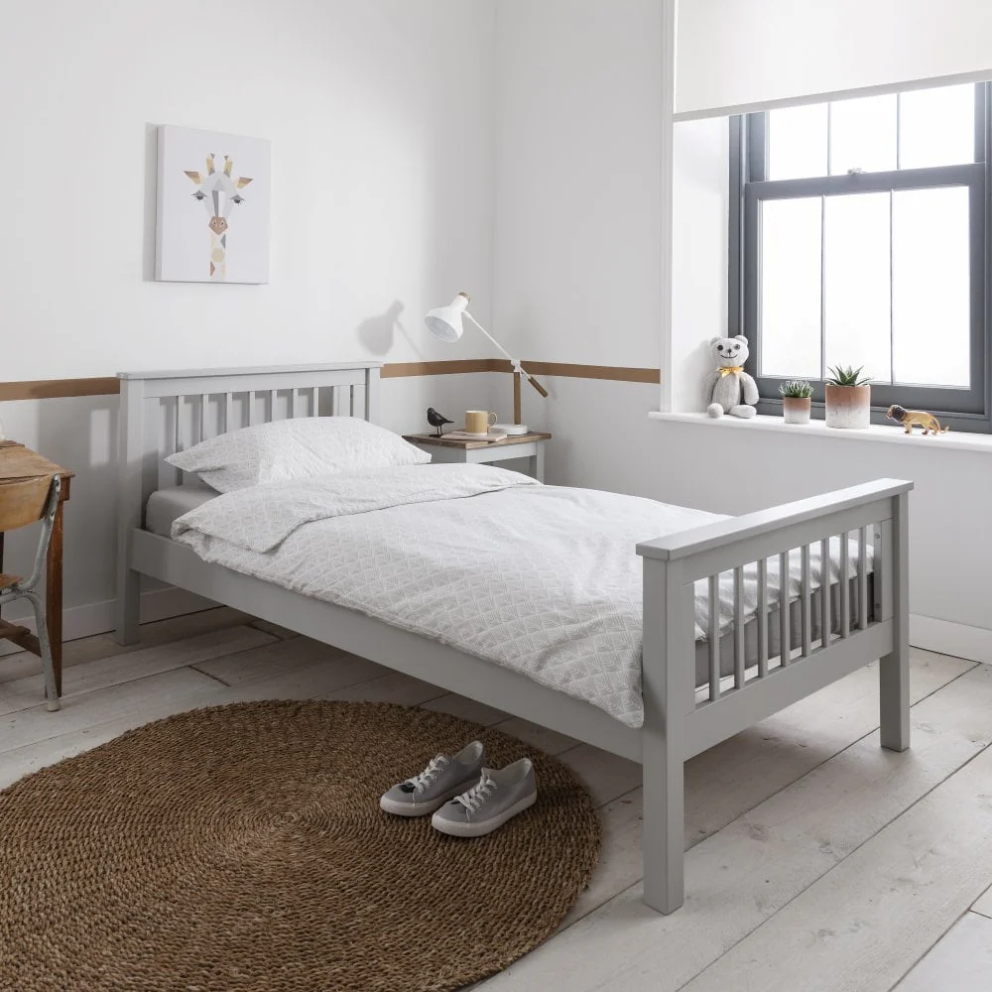
- Sigle bed
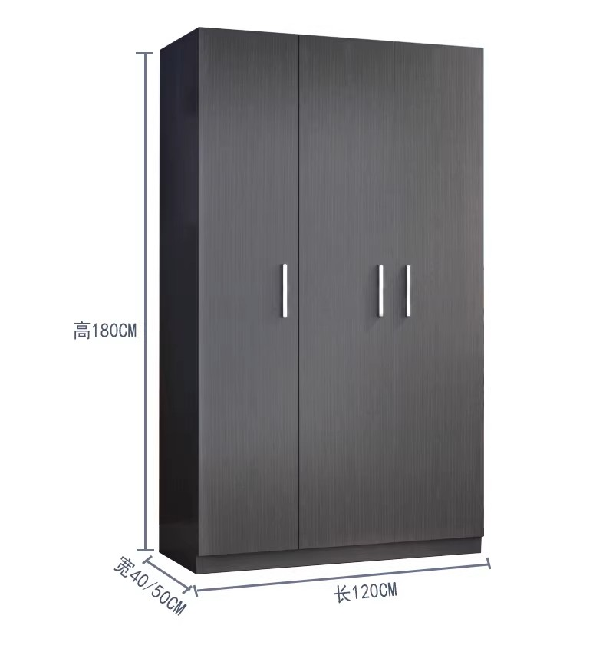
- Wardrobe

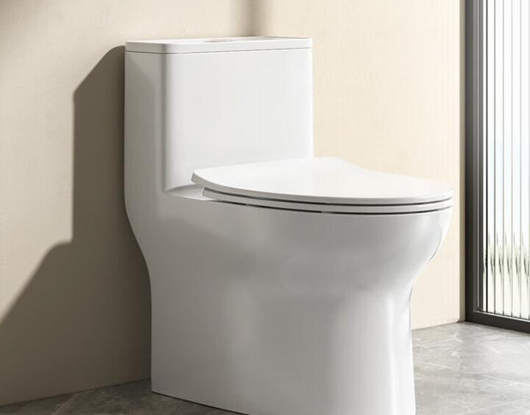
- Toilet
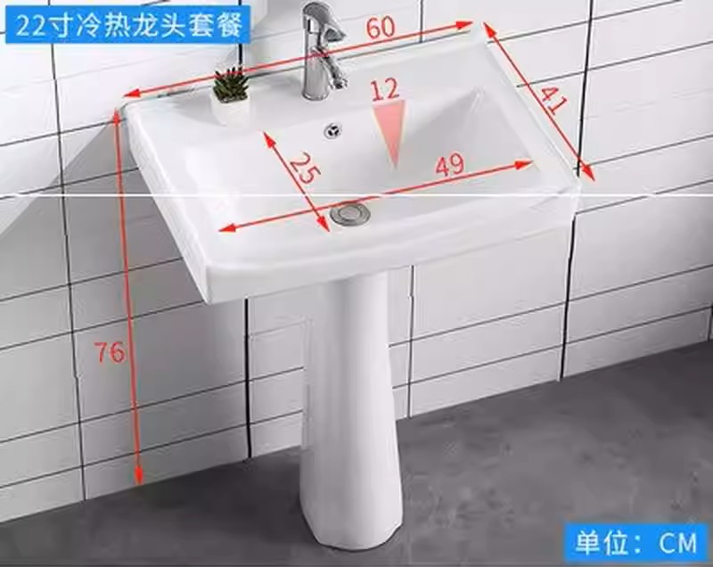
- Washbasin
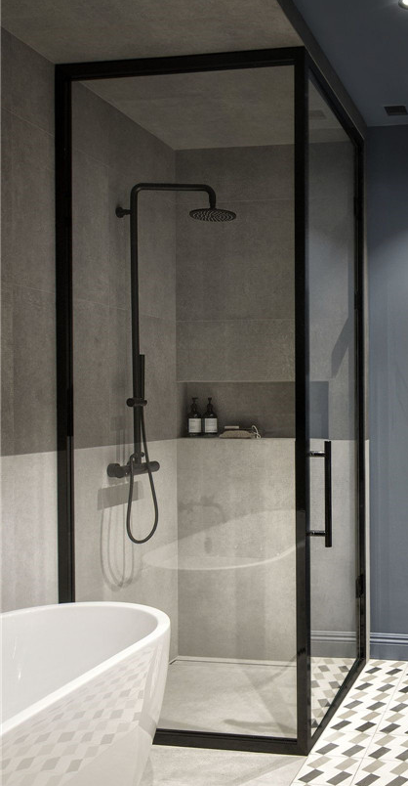
- shower cubicle

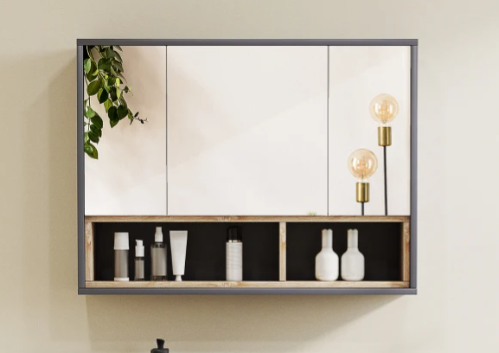
- wall cupboard
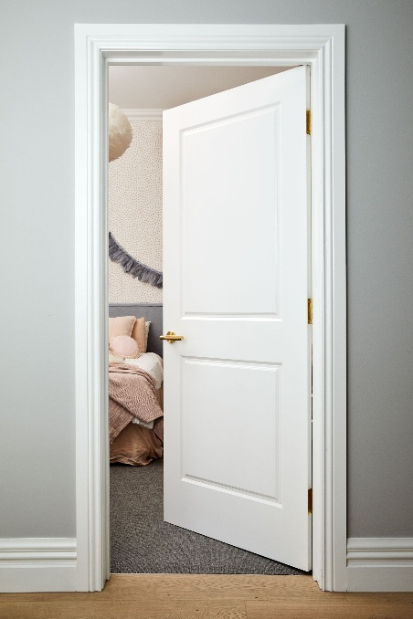
- Door
- Room decorations (books, bag, suitcase)

