The Verdant Trail

Level Breakdown & Art Execution Documentation
I. Overall Level Structure Overview
This project adopts a phase-based narrative progression structure.
The map is divided into clearly defined functional spatial units, gradually unlocked through a “Reputation System.”
Overall progression structure:
Basecamp
↓
Phase 1: Meadow
↓
Phase 2: Forest
↓
Cabin Interior (Optional Standalone Scene)
↓
Phase 3: Salmon Run
↓
Phase 4: Cave
↓
Final: Watchtower
This structure follows a linear narrative-driven progression with conditional exploration unlocks.The project is not an open world, but a controlled progression spatial narrative system.

II. Scene Structure Recommendation
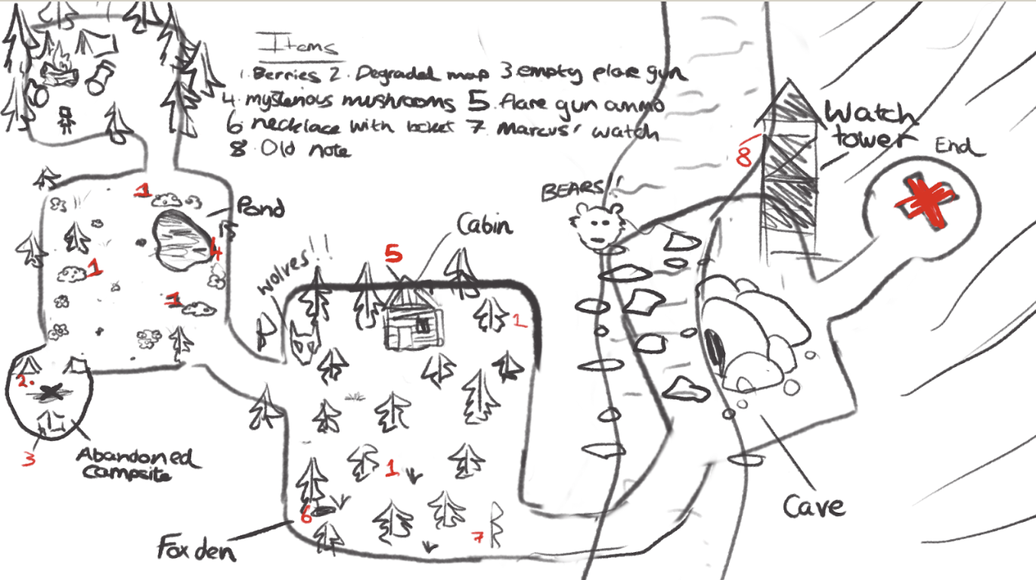
To ensure production efficiency and performance stability, the following Scene breakdown is recommended:
Scene 01 – Meadow (including Basecamp) →Scene 02 – Forest → Scene 03 – Cabin Interior → Scene 04 – Salmon Run →Scene 05 – Cave →Scene 06 – Watchtower Cave and Cabin are recommended as separate Scenes due to entirely different lighting and post-processing systems.

III. Level Breakdown & Art Direction Notes
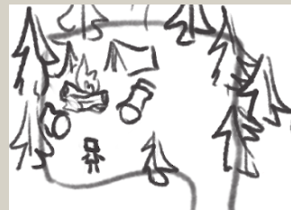 Phase 1: Meadow
Category | Description
Level Role | Tutorial phase / Reputation system introduction / Establishing vulnerability
Progression Condition | Sierra Reputation ≥ 20% (Compass acquired)
Spatial Type | Open space
Composition Logic | Horizontal expansion / Low horizon line / Large negative space
Player Flow | Fan-shaped exploration / Abandoned campsite as focal point
Key Landmarks | Abandoned camp / Lake
Emotional Tone | Exposure / Unease
Color System | Warm green + Withered yellow
Lighting Strategy | Bright but soft / Minimal shadows
Occlusion Ratio | Low
Enemies | None
Key Items | Weathered Map / Flare Gun / Mushrooms
Asset Modules | Grass ×3 / Trees ×2 / Rocks ×1 / Flowers ×1
Technical Focus | Spatial openness control > Asset density

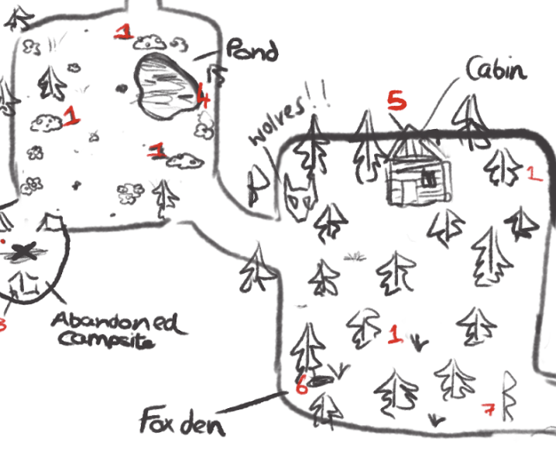 Phase 2: Forest
Category | Description
Level Role | Mid-game oppression / Enemy introduction / Cabin zone
Progression Condition | Reputation ≥ 50–60% to access river section
Spatial Type | Semi-enclosed maze
Composition Logic | Strong vertical lines / High occlusion / Compressed visibility
Player Flow | Curved path / Cabin as northern focal point
Key Landmarks | Cabin / Fox den
Emotional Tone | Overwhelmed / Oppressed
Color System | Deep green + Blue-gray
Lighting Strategy | Cold, dim lighting / Light fog / Heavy shadow contrast
Occlusion Ratio | High
Enemies | Wolves
Key Items | Locket / Marcus’ Watch
Asset Modules | Pine trees ×4 / Fallen logs ×2 / Moss ×1 / Fog layer ×1
Technical Focus | Tree occlusion layering management

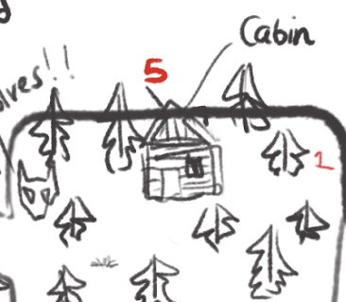 Phase 3: Cabin Interior
Category | Description
Level Role | Human trace environment / Ending C clue space
Progression Condition | Accessible after Forest exploration
Spatial Type | Fully enclosed interior
Composition Logic | Wood structure / Reinforced dark corners
Player Flow | Main hall → Stairs → Basement
Key Landmark | Basement cabinet
Emotional Tone | Decay / Abandonment
Color System | Dark brown + Warm/cold contrast
Lighting Strategy | Localized warm lighting / Strong shadow contrast
Occlusion Ratio | Medium–High
Enemies | None
Key Items | Ammo / Ritual cabinet
Asset Modules | Wood wall ×1 / Table & chair ×1 / Stairs ×1
Technical Focus | Independent lighting system per Scene

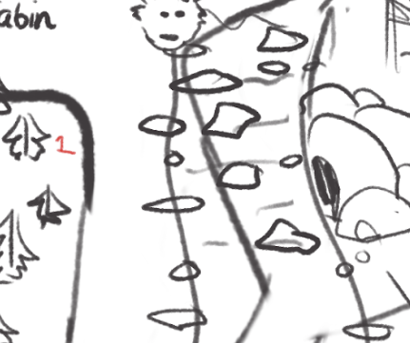 Phase 4: Salmon Run
Category | Description
Level Role | High-risk linear zone / Bear encounter
Progression Condition | Unlocked after reputation threshold
Spatial Type | Linear traversal
Composition Logic | River guiding path / Rhythmic rock stepping points
Player Flow | Single-direction stepping stone path
Key Landmark | Cave entrance across the river
Emotional Tone | Danger / Tension
Color System | Cold gray-blue
Lighting Strategy | Strong contrast / Water reflection highlights
Occlusion Ratio | Medium
Enemies | Bear
Key Items | None (Progression-focused)
Asset Modules | Rocks ×2 / Water body ×1
Technical Focus | Bear scale ≥ 3× character height

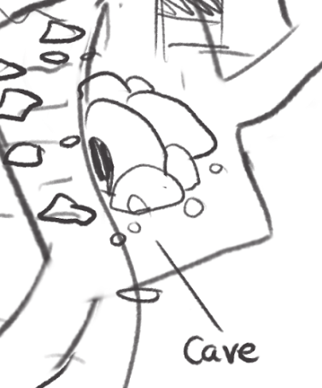 Phase 5: Cave
Category | Description
Level Role | Emotional lowest point / Psychological collapse
Progression Condition | After completing river section
Spatial Type | Compressed interior space
Composition Logic | Low ceiling / Irregular rock surfaces
Player Flow | Entrance → Compression → Expansion → Compression → Exit
Key Landmark | Skull zone
Emotional Tone | Despair / Temporal distortion
Color System | Cold gray / Desaturated
Lighting Strategy | Cold entrance light → Dark mid-section → Slight warm exit
Occlusion Ratio | Extremely high
Enemies | None
Key Items | None
Asset Modules | Rock wall ×2 / Skull ×1 / Water drip FX ×1
Technical Focus | Post-processing intensification (Vignette / Grain)

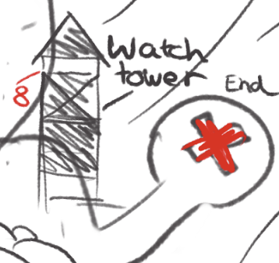 Phase 6: Watchtower
Category | Description
Level Role | Final climax / Ending trigger
Progression Condition | Unlocked after Cave
Spatial Type | Vertical emphasis
Composition Logic | Tower as highest object / Visible from distance
Player Flow | Climbing progression
Key Landmark | Watchtower summit
Emotional Tone | Release / Hope
Color System | High contrast
Lighting Strategy | Strong separation of light and shadow
Occlusion Ratio | Low
Enemies | None
Key Item | Flare activation point
Asset Modules | Tower structure ×1 / Stairs ×1
Technical Focus | Clear distant silhouette

IV. Emotional Progression Curve
Phase | Spatial Density | Lighting | Psychological State
Meadow | Low | Bright | Uneasy
Forest | High | Cold & Dark | Oppression
River | Medium | Cold High Contrast | Tension
Cave | Extremely High | Extremely Dark | Despair
Watchtower | Open | High Contrast | Release
The Cave represents the emotional lowest point. The Watchtower represents the visual and emotional climax.
V. Visual Hierarchy Standards
Rendering order:
Background
Environment
Characters
Props
FX
UI
All Sprites:
Filter Mode: Point
Compression: None
PPU: Globally unified

VI. Production Priority (MVP)
Phase 1: Meadow + Forest edge
Phase 2: Cabin exterior + Fox den
Phase 3: River section
Phase 4: Cave
Final: Watchtower
Production principle: Emotional clarity > Spatial scale > Asset quantity

VII. Summary
The level structure emphasizes:
Emotional escalation、Spatial compression shifts、Landmark guidance、Conditional unlocking、Psychological lowest point (Cave)、Vertical release (Watchtower)，This is not an open world, but a controlled narrative spatial system.

